UCD Requirement Specification

Section 1

Overview

The website that I will be creating is one based on a catering company called Dignans. Dignans have asked for a website to be created that will expand their business further to a wider customer base. Their customers will be able to use the website to be able to place orders, find relevant contact information, prices, and other services that they offer. The website will not only be useful for the customers but also for Dignans and their staff as they will be able to use the site to check up on orders and keeping the menu up to date with availability.

Requirement Specification

The requirement specification comes from the owners of Dignans the purpose is to provide specific requests that they want the developers to implement or carry out from them. This information is valuable because without the specification document the developer may create a website that is not fit for purpose which could cause Dignans to be unhappy with the final product.

Assumptions

Customers

* Mobile Phone, Tablet
* Google Chrome, Edge, Firefox
* Home, Work environment, mostly well-lit area, quiet or noisy setting.
* Not much prior technology experience required in order to view and browse the website.

Dignans Staff

* Mobile Phone, Tablet, Desktop, Laptop
* Google Chrome, Edge, Firefox
* Work Environment, Well-lit area quiet or noisy setting.
* Sufficient training / knowledge on the website and its extended access to databases pertaining order information and relevant contact information etc.

Constraints

* Unstable internet connection can cause the website to not function as intended.
* Not having required knowledge on how to use the website for staff. This can cause disruptions to work.
* Insufficient Permissions can prevent administration tasks from being completed, this can be things such as Viewing / Managing user data, user analytics etc.
* Not creating accessibility options can prevent some customers from using the website, this can be options such as Dark Mode, Font size zoom etc.
* Any database issues can cause customer orders to not come through which can cause them to be unhappy with the company’s service.
* Confusing customer / user journey. We want to make ordering on the website as simple as possible.

User Persona 1

Susan is a 32-year-old woman living in Edinburgh, she has decent knowledge and experience with the use of a computer as she has an office job therefore, she will have no problem browsing the company website to look them up. In the office Susan oversees organising and planning all work events.

User Scenario 1

Susan is attempting to organise a work event with Dignans and is looking to get a service outdoors such as food, drinks etc. Susan will be going onto this website and purchasing the specific service that caters her needs perfectly. She will be using the website to check out what food is on offer along with prices to see if this falls within her budget. She will also be needing to get the companies contact details in order to finalise the request.

Task Analysis 1

1. Open Browser of choice.
2. Navigate to Dignans website.
3. Browse the website to find the specified service offered.
4. Fill out form detailing which service they would like.
5. Enter in Contact and payment details accordingly.
6. Click Submit.
7. Wait for further contact from Dignans.

User Persona 2

Liam is a 24-year-old man working in Edinburgh at a company called Dignans. Liam has lots of experience in hospitality and practical cookery. Liam is confident using technology and has a wide range of experience using all sorts of different electronic devices. He has worked for Dignans now for 2 years.

User Scenario 2

Liam is getting some orders ready when a notification pops up on the Staff Database detailing a new order that has just came through. He will have to finish up what he is doing and review the new order to ensure that they can take on the new order and have enough supplies and staff to complete the order that’s been asked of them in the timeframe needed by the customer.

Task Analysis 2

1. Pick up tablet.
2. Open database.
3. Obtain details on order.
4. Check stock levels.
5. Check staff availability.
6. Contact customer to Approve / Reject order.
7. Carry out order.

Section 2

Functional Requirements

* Hyperlinks, Links taking you to relevant information about a product, whether it be more information or images linking to it.
* Cart / Basket, A function that allows the user to add services to a final total area which then would lead to adding relevant payment information.
* Branding, the website will need to have Dignans branding to signify that it is the official website for the company.
* Search bar in the navigation, can allow for users to search for anything on a website.
* Ability to create an account with Dignans so orders are stored so the customer can refer to them.

Home Page

* Detailing the company, who they are, what they do, where they are based and other relevant information such as a
* Site Map, used to assist navigating through a busy website, keeps user confusion and frustration low.
* News, a section on the webpage dedicated to new information on the company, can also be an area to share images, latest food trends and more.

Services Page

* Detailing all the products and services the company, Dignans offers to the general public.
* It should include information, Imagery, Prices and an add to cart option.

Reviews Page

* A simple subpage where you can view and read customers reviews on the company, this is useful for a new customer to see how the company performs in reality and can promote user engagement allowing them to give their thoughts and potential feedback on Dignans.

Contact Page

* A Contact page, so you can get in touch with Dignans with any queries.
* This can also use a form on the subpage, will also make the site look professional.

User Interface Requirements

* General colour scheme, the website should follow a simple colour palette that fits with the companies’ goals and logo.
* Keep bright colours to a minimum, find a couple colours that go well together and use that throughout the whole site.
* You should also not be too loud with the colour usage as this will be the first thing the user sees when visiting the website, having a bright front page can seem jarring and can give the user eyestrain which can cause the user to have a bad experience which can damage the company’s reputation.
* Font usage, should always make sure you are using the right font, whether it be sans or sans serif, this can drastically change the mood of the text being used on the website and overall text readability due to serif being hard to read in a smaller font size etc.
* ‘Add / View Basket’ menu, having this in the page navigation will allow the user to view added items that they wish to buy with ease, keeping the interface simplistic can allow people of all ages to use the site.
* Sign Up / Sign in, having this can lead to the user being able to save / bookmark products, offers or pre orders of products not out yet, this also would give the company access to their email address where you can then send newsletters, content about sales and more.
* Have a button on the navigation menu that will take the user directly to make an order, this will help a returning user that wouldn’t need to go through multiple pages on the website before ordering.
* Search menu, having a search option on the page can allow for ease of access to specific information laid out on the site.
* Using simple user interfaces will guarantee user Efficiency, Satisfaction and more, if the user is happy with the interface and it works, they will enjoy their time on the website more allowing them to spend more time on it.

Usability Requirements

* Efficiency, ensuring that goals or tasks set out by the user can be done at a timely manner and require little to no effort, keeping this down can ensure the user will like the site.
* Making sure the user interface is easy to learn, navigate and use, this can be with buttons, text, prompts and error messages.
* Error messages, keeping the error messages simple and minimal if possible is key, for an example with Microsoft Windows, the Infamous ‘blue screen of death’ only shows a small bit of text saying “Your PC ran into a problem and needs to restart” followed by a sad face and some other key details like a progress bar and some technical support information. This new error screen keeps user frustration and fear to a minimum.
* Accessibility options, all users should be able to view and access all public areas of a website no matter the visual or physical impairment, you can do this by giving the user some options like: Dark Mode, Bigger font size, image alt text and contrasting options, there are many options out there you can implement into a website.
* Screen clutter, keeping side page content small will keep a page looking clean and can keep a website looking professional, less busy and allow readability to be at an all-time high, keeping things off screen can include the use off too many ads or irrelevant information.

Performance Requirements

* Due to Dignans being a small business looking to grow further, they would want to allow for 20-100 concurrent users to be able to use the website at the same time.
* We would want the system to be able to calculate customers’ orders especially if they are adding multiple items and store them to the database without getting them mixed up with other orders.
* They want the ability for multiple users to be able to make an order at the same time without the site crashing or overloading.

System integration Requirements

System integration can be a great thing to seriously improve your future users experience on the website, whether it be quality of life integration or integrations that are required for the website to function some examples can be:

* PayPal integration, this would help with payment options. Having PayPal as a valid option of payment can overall grow the audience that might be buying things from your webpage and can boost your E-Commerce site.
* Twitter Integration, this could allow a section of the website to be dedicated to an official twitter account, this section will show recent tweets, retweets or even old tweets posted by the company themselves or a social media manager / admin.
* Availability Calendar, using this can make the task of organising when a company is free to assist you as simple as possible, as this will not waste the users time if there is no availability on that day.
* Videos, integrating videos on platforms like YouTube, Twitter, Instagram, Facebook etc can be a great way to survey information to a user, sometimes the user would prefer to watch something than read a large body of text.

Security Requirements

Ensuring that your webpage is secure along with all the data with it is a serious priority, as you must abide by GDPR (General Data Protection Regulation) as if you are caught in breach of this regulation can cost you a hefty fine, you can ensure to secure things such as:

* SQL Database, ensuring that your database is secure from any hostile injection code.
* Ensuring password storage is never in plaintext and is always hashed
* Never store things on client side that can be stored in a database on server side
* If a data-breach does unfortunately occur, you **MUST** inform all of your users of the breach as this falls into the GDPR Regulation.

Dependencies

Yes, there is a possibility that you could require a server hosting company to run and maintain the services and maintenance on the backend of the website, this would include allowing users and staff to access the site 24/7. However, if you didn’t do this you would have to have the expertise to run and manage the webserver yourself.

Data Management Requirements

As stated above in other points there are various rules and regulations in place to ensure that the security of personal data is enforced and secure from hackers or fraudulent activity, if a database was to be used within this webpage you will have to go through extended lengths to ensure the security of the data held within. Some of the data that can be found in the theoretical database can be:

* Peoples Names, usually the names of the users who have signed up for the website, bought something on the website, this can also include payment information holding names.
* Addresses, this would also be included within payment information used securely, these addresses could also be used for shipping packages to the individual.
* Banking information, this is a very important piece of data that should be protected through heavy encryption, hashes etc

The data said above would be used on a day-to-day basis from the user or even the company to fulfil orders or queries by the user / individual. If your company is in breach of the GDPR you may be given a fine up to 20 million Pounds and can severely damage your company’s reputation.

Standards Compliance Requirements

* General Data Protection Regulation, this is a privacy regulation in place to ensure the privacy of Citizens, everyone is responsible for using personal data and must follow strict data protection principles, ensuring that information is used lawfully, transparently, and fairly.

Data must be stored and handled securely using protection against unlawful or unauthorized processing, access, or damage.

* Cookie consent notices, with collaboration in GDPR your website must have a cookie policy and consent notice for example (click here to agree to our cookie policy) can be found on many websites requesting your permission to store your cookie history.

You must also describe why your website is using cookies, disclose what the user is agreeing or accepting too etc.

* HTTPS, you must ensure if the webpage you are making is within the e-commerce theme is using HTTPS (Hyper-Text Transfer Protocol Secure), not using a secure https (http) can expose user data information such as Credit card payment information, emails, passwords etc.

Portability Requirements

You can do a couple things to make your website more portable and accessible to everyone such as:

* Allowing the website to be viewed on other devices such as Mobile Phones or Tablets. Over the years mobile phone usage has been used for shopping, browsing etc. Allowing your website to run on a mobile phone or tablet will allow a larger target audience to people who don’t own a laptop or desktop computer.
* Allowing website content to be scaled up or down for easier viewing / reading, giving a mobile phone user the ability to ‘zoom in’ to bodies of text can make user experience and efficiency easier.
* Another option for Dignans to expand their capabilities would be to build a mobile application so that users can download it and view from all mobile or tablet devices at the click of a button rather than needing to search through the internet.

Section 3

Wireframes

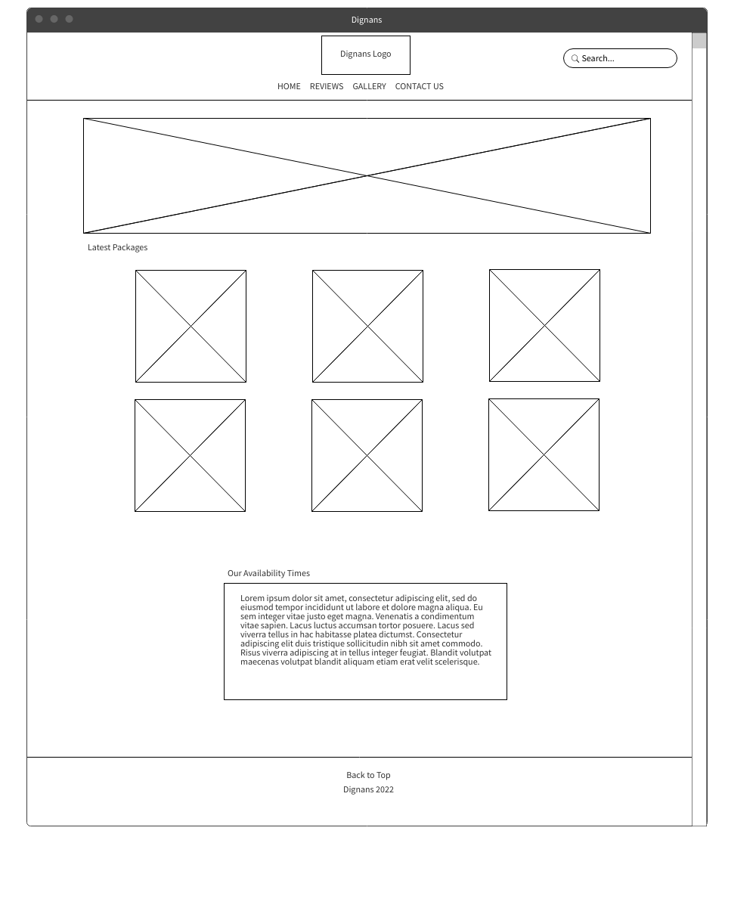Desktop:

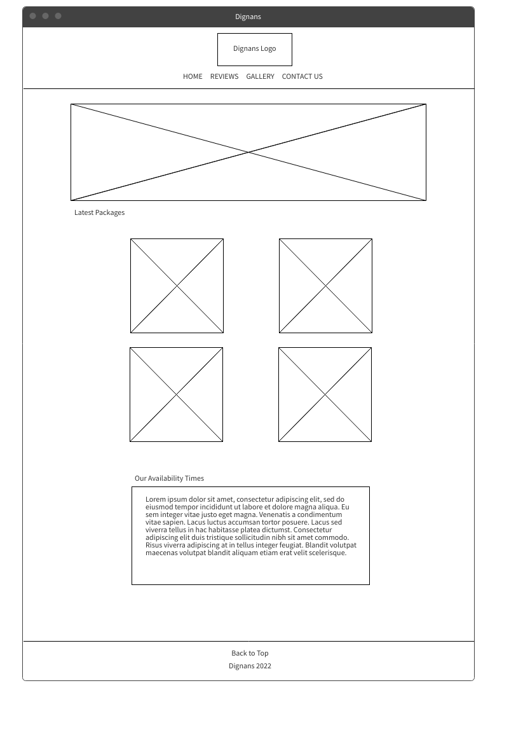Tablet:

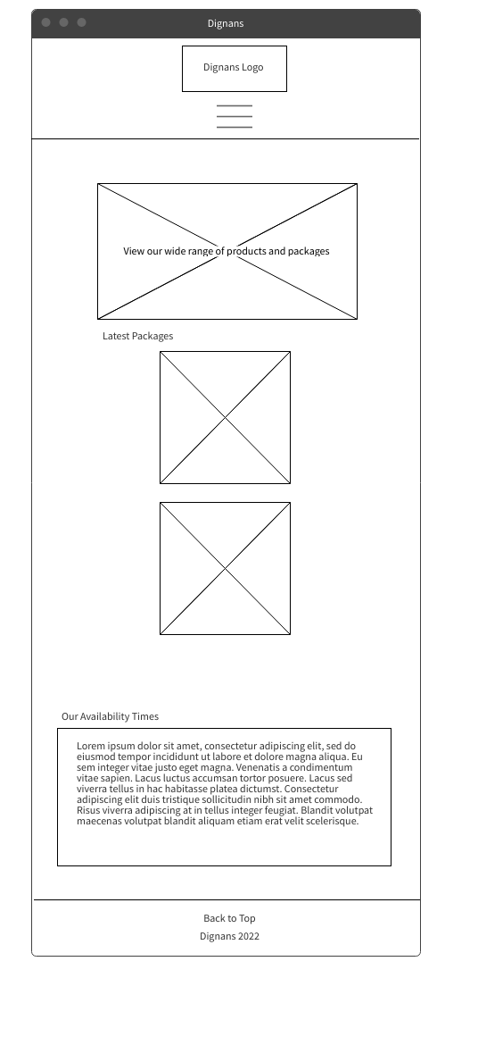Mobile:

Wireframes 2

Desktop:

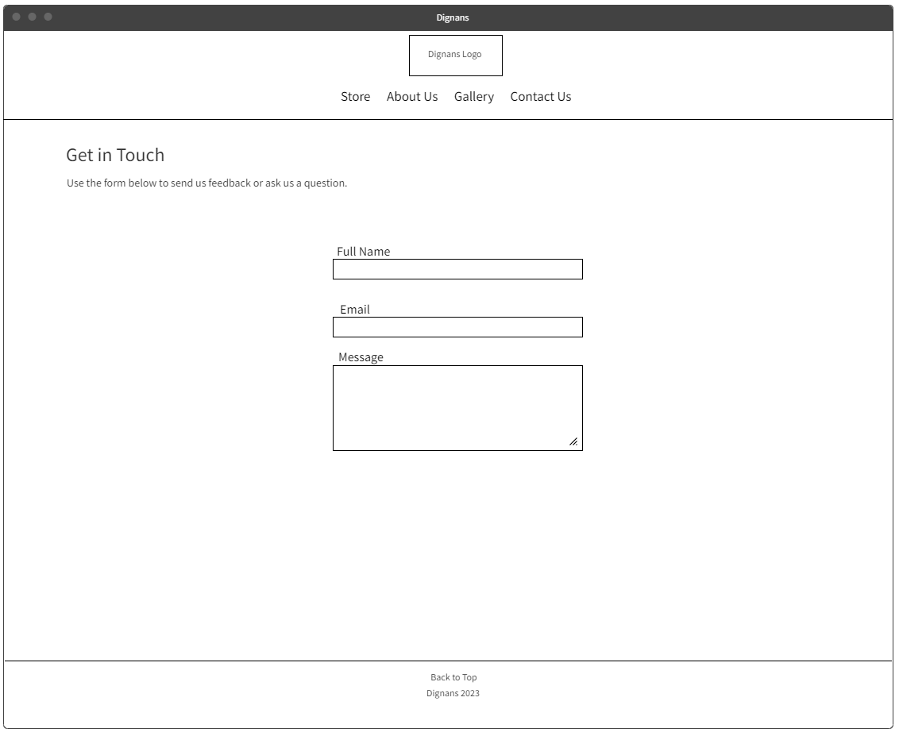

Tablet:

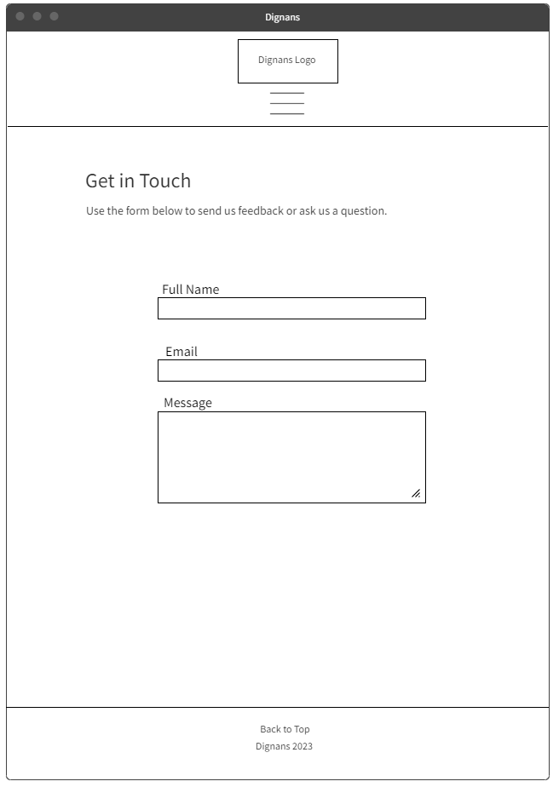

Mobile:

Visual Prototypes

Desktop:

Tablet:

Mobile:

Visual Prototypes 2

Desktop: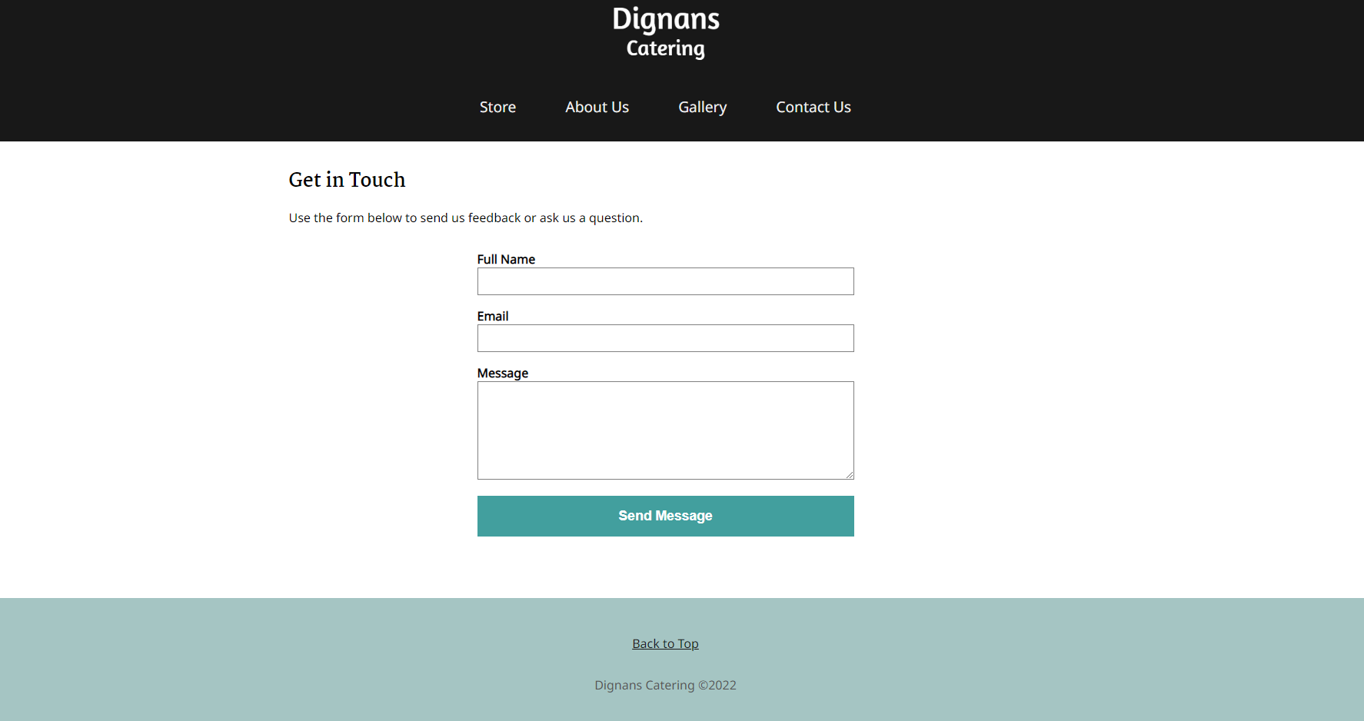

Tablet:

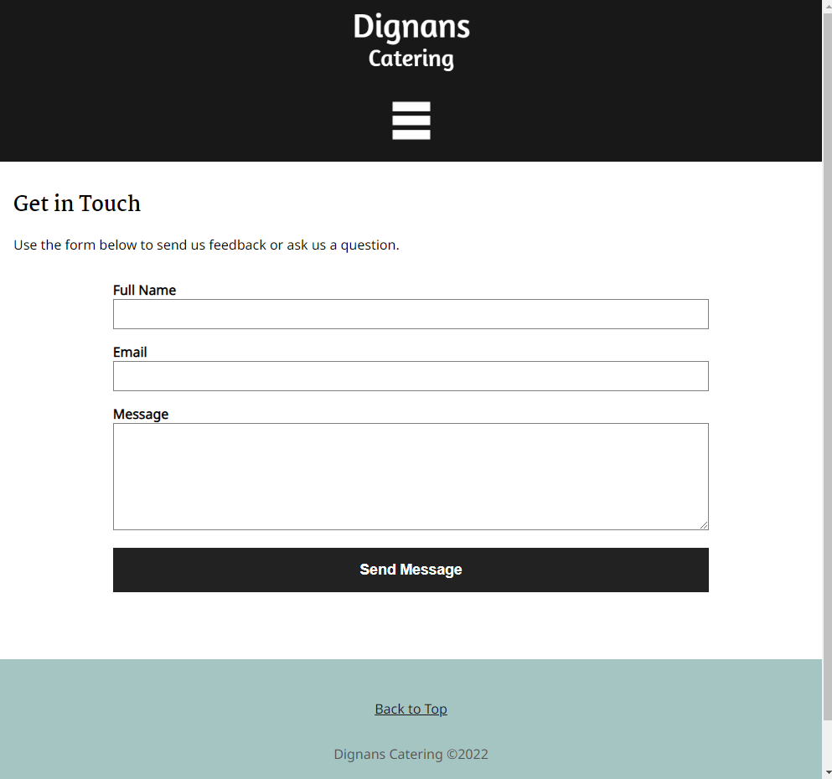

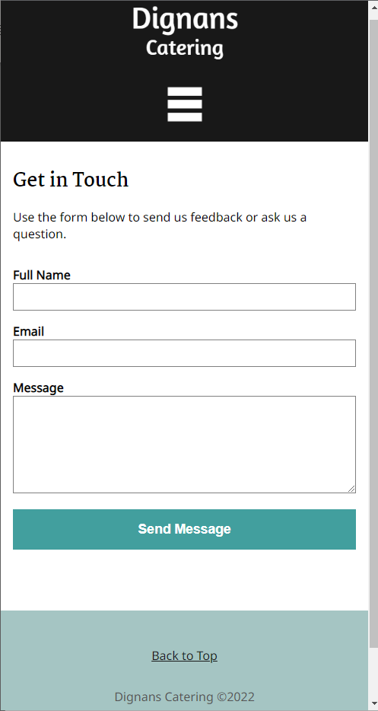Mobile

Style Guide

Site Map

Design Justification

Effectiveness of Colour Schemes

Throughout the webpage I have thought long and hard on what colour scheme I will be using, in the end I decided to go for a monochromatic approach with green. Starting with the header I decided to go with a light shade of green, footer and buttons are a darker forest green, background is white though the whole page and ending with black for Text. I believe this choice is great for the page as it allows for user viewing to not seem jarring and busy whilst not looking dark / dull whilst still maintaining user efficiency by being able to read the text portrayed on the site. The reason I decided to go with green was due to the nature of Dignans being an outdoor catering company, green is commonly matched with the environment such as trees, grass etc. green also gives off similar emotions of Organic, Restoration and Peace. Using these emotions, we can keep users calm and collective which will lead to maximising user efficiency and experience.

Appropriate use of Typography

Within this webpage I chose a few fonts to use such as Amaranth, Signika Negative and Font Awesome. All of these fonts share a common factor, that they are all sans-serif fonts. Sans serif is better than serif as it allows for maximum text readability where serif does not. Amaranth font was used to create the Dignans Logo displayed at the top of the navigation on the webpage, Signika Negative is used within the body and headings on the site. This font allows for easy reading upon the eye with no sharp edges on text giving the site a welcoming and friendly emotion to the new user and Font Awesome is used for the star ratings section of the review page that allows a user to see clearly how many stars a review has. Font Awesome is an icon-based font rather than a traditional font that contains letters, this simple addition stands out to the user whilst they are on the website. Having your website be accessible and friendly can attract new users and make them want to come back which should be quite important to a company and its goals.

Graphic Design Principles

Starting off with Balance: Over the entire webpage this graphic design principle can be seen within the elements of imagery and text, ensuring that content is placed evenly is quite important to giving your website the professional look that it requires.

Consistency: After creating this webpage a main thought on mind was to keep the design and interface as simple as possible, this can ensure that anyone who decides to view the page will not have any problems at all navigating the site. This can also be seen within the Colour scheme picked, the site is only using at max 3 colours which is perfect as this means the entire page is using the same colour Palette throughout, keeping user confusion and frustration at minimal levels. Regarding buttons on the page, they are using curved edges as this promotes safety and friendly emotions to a user, if you use sharp edges this can let off an effect of danger and unsafe which might deter users.

Alignment: The site’s alignment is quite easy to spot as each element is placed evenly between each-other with a few elements placed differently as you can see on the main page, the December events content is placed on the left and right aligned perfectly on each side of the page. This can ensure that the page is kept clean, tidy, and professional.

Proximity: As I have mentioned briefly in the above principles, Content that is corresponding to its section is placed next to each other to keep user confusion minimal, each section is labelled above or within. For example, the December events section has Christmas and new year directly underneath it.

Emphasis: This website is making use of bold, underline, italicised text, and Font sizing. Using these can trick the human mind into wanting to read certain content before others like headlines or other important details you should know before continuing. For Example, you can see on the website if you hover over a button, the button moves to a darker shade of colour to signify you are hovering over to click it, or within hyperlinks if you hover the cursor over it, it will underline.

Hierarchy: This can be seen throughout the entire site, some text is placed bigger than others to signify importance which can also work together with Emphasis, ensuring header text is bigger than the content below can ensure the user will read that header before anything else.

White Space: Throughout the page white space is extremely important to cut alternate content away from others. This website is making use of white space as the key background colour for the website. Keeping the site clean and not busy can reduce user cognitive load. An example of this would be keeping massive bodies of text low and unnecessary content off screen.

Graphic Design Elements

This webpage is making use of a few shapes like lines, stars, ovals, squares etc. Starting with the reviews page you can see a star shape placed next to some client reviews, these small details can go a long way for a new user reviewing the site and fits rather well within the review content section. Another use of Lines is when the Menu / Product page. You can see a small line placed under some Headings which looks quite nice. Ovals are being used for the buttons throughout the website, keeping the buttons round edge shape can keep the page looking professional, friendly, and safe to all users. The round edges are welcoming due to how you can get hurt from sharp surfaces if you were to attempt to touch them.

Now moving onto Imagery, this website is using a good number of images to convey theme to certain content like, the home page is using images showing what product selection the company is offering, or within the review page there is a user profile image which can signify a real person took time out of their day / night to post their thoughts and feedback on the company. I feel with the images chosen they fit the website’s theme and goals.

Overall Usability

At the end of the day, this website’s overall usability is rather efficient and simple. Text placed on the page is easily readable by users with little to no hassle, The page content is placed in a way that would make a user remember it. The website that I have created ensures that the end user can complete a task with minimal effort needed this is a great way to keep the user happy. Regarding Error Tolerance, it couldn’t be simpler as there is little to no opportunities for the website to fail. Another factor to the usability of the site is how simple the user interface is to learn due to how minimalistic it is. Therefore, it shouldn’t take long for anyone to figure out how to navigate the site no matter the technical experience.

Within the interactive element’s topic, they work as you would expect them too, for example: If you hover over a button, it should display a pointer that you have it selected, whether that be an underline or a darkened colour, this makes the users selection stand out so they cannot miss what area they are trying to navigate into. Content placement within the site is kept minimal to avoid user confusion, frustration, and hassle which is a massive priority as we want to allow people of all capabilities to be able to use the website.